1. CRYSTAL STRUCTURE
Solid Materials
Crystalline Materials | Non-Crystalline Materials (Amorphous)
Eg. All metals, Some Ceramics, Quartz. | Eg. Plastic, Rubber, Glass (Ceramics)
High Strength | Low Strength
Anisotropic/ Un-isotropic | Isotropic
Sharp & High melting point | Low & Range of melting point.
Bravis Lattice System (Types of Unit cells):
Total Number of Lattice System = 14 | Basic or Primary Lattice System = 7
Cubic System | Triclinic System
$$a=b=c, And α=β=γ=90,$$  $$Number of parmeter required to describe system$$  $$(n)=1$$ | $$a≠b≠c, And α≠β≠γ≠90,$$  $$Number of parmeter required to describe system$$  $$\left(n\right)=6,Most Complex Structure$$

- Number of Atoms Required to form Cell (N):  - Number of Atoms Inside the unit Cell (n):  - Side length given by parameters ($a,b,c$):  - Bond Length: Minimum Distance between two atoms.  - Atomic Packing Factor (Packing Density): Total Volume of atom / Volume of Unit cell | - % of Empty Space in Cell:  - Coordination Number: the number of atoms or ions immediately surrounding a central atom in a complex or crystal.

 | Simple Cubic Structure | Body Centred Structure | Face Centred Cubic Structure | Diamond Cubic Structure/ Face centred Tetrahedral | Hexagonal Closed Packed Structure (HCP)
1 | 8 | 9 | 14 | 18 | 17
2 | 1 Atom | 2 Atoms | 4 Atoms | 8 Atoms | 6 Atoms
3 | $$a=2R$$ | $$\sqrt{3}a=4R$$ | $$\sqrt{2}a=4R$$ | $$\sqrt{3}a=8R$$ | $$\frac{c}{a}=1.634 \& a=2R$$
4 | $$2R$$ | 2R | $$a/\sqrt{2}$$ | $$8R/\sqrt{3}a$$ | $${\frac{2R}{a}}/{\frac{c}{1.634}}$$
5 | 0.52 | 0.68 | 0.74 | 0.34 | 0.74
6 | 48 % | 32 % | 26 % | 66 % | 26 &
7 | 6 | 8 | 12 | 4 | 12
Eg. | Plutonium | W, Iron (α-Fe), Cr, Na | Ni, Al, Au, Ag | Diamond, Si, Ge | Zn, Co, Mg, Ti, Be, Zr

Crystallographic Directions: Line Drawn within unit-cells (Simple Vector). |  | Single Direction = $[x, y, z]$
Miller Indices: Integer denotation of Reciprocal of Plane Fraction. |  | Family of Direction = $<x, y, z>$
Crystallographic Plane:  Procedure: 1) Locate Origin in 3d, 2) Find plane fraction, 3) Reciprocal And convert in to integer number by multiplication. |  | Single Plane = $[miller indices]$  Family of Direction = $\{miller indices\}$
$$Linear Density=\frac{Mass}{Volume}=\frac{No. of Atoms in a Direction}{Length of direction}$$
$$Planner Density=\frac{Mass}{Volume}=\frac{No. of Atoms in a Plane}{Area of Plane}$$
$$Inter Planer Distance \left(d\right)= \frac{1}{\sqrt{{\left(\frac{h}{a}\right)}^{2}+{\left(\frac{k}{b}\right)}^{2}+{\left(\frac{l}{c}\right)}^{2}}}$$ | Where, $(h,k,l) = Miller Indices$,  $a ,b ,c = Lattice Parameter$.

X-ray Diffraction Method (Brag’s Method 1912):  $$E∝\frac{1}{λ}$$  $$AB+BC=nλ$$ | 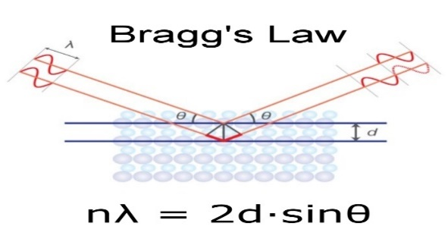 | $n$ = Order of reflection EG. 1,2, …  $λ$ = Wave Length of X-ray,  $θ$ = Brag’s Angle,  $2θ$ = Deflection Angle,  d = Inter Planer Distance.

IMPERFECTIONS IN SOLIDS/ DEFECTS
Point Defect (0 D) |  | Line Defect (1 D) | Surface Defect (2 D)
Intrinsic Defect | Extrinsic Defect | - Edge Dislocation  - Screw Dislocation | - Grain Boundary  - Tile Boundary  - Twin Boundary  - Stacking Fault
- Vacancy  - Frenkel  - Schottky | - Substitutional  - Interstitial

Point Defect: Missing or Miss Placing of Atom.
Intrinsic Defect: At high Temperature. |  | Extrinsic Defect: Adding Impurity.
Intrinsic Defect
Vacancy Defect: Missing Atom | Frenkel Defect: Misplacing of ion (Mostly observed in Ionic Crystal NaCl) |  | Schottky Defect: Missing of pair of atoms Atom. Electrically balanced effect
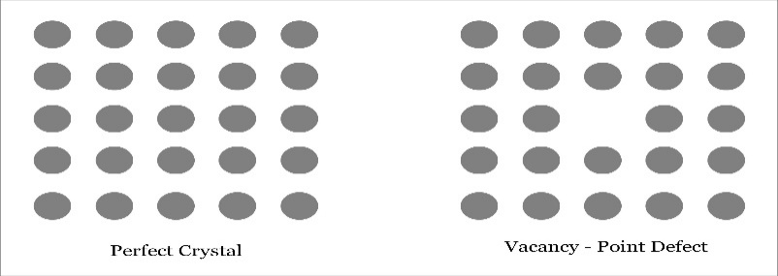 | 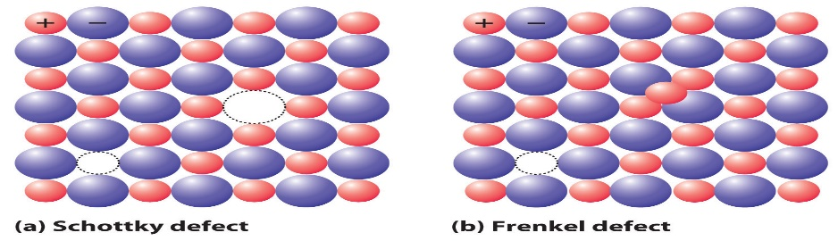 |  | 
Extrinsic Defect
Substitutional Defects | Interstitinal defect |  | 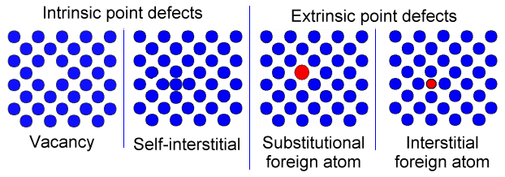
- Adding foreign Atom in place of host material atom  - Size of Foragn atom is similar to Host atom.  - Strenght is not changing And other properties changes.  - Eg, Cr + Steel (Corrosion Resistance increase) | - Adding Impurity atoms at intersitional position.  - Size of Foragn atom <<<< Host atom.  - Strenght And other properties changes.  - Eg. C + Fe ( Strength Increases)
Defects Are not bad.
Line Defect (1 D) |  | 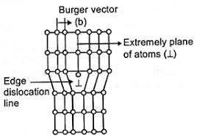
Edge Dislocation:  - Dislocated atoms move parallel to F.  - Only Translatory direction.  - Burger vector is parallel to F and perpendicular to dislocation | Screw Dislocation:  - Dislocated atoms move perpendicular to F.  - Initial is translatory direction and followed by rotational/ Screw motion)
Burger’s Vector: Gives direction and magnitude of dislocation.

Hall Petch Equation:  Relation Between Strength and Grain Size.  $$σ=σ_{0}+K/{\sqrt{d}}$$ | $σ$ = Strength of material,  $d$ = Grain Size,  $σ_{0}$,$K$ = Constants for material.
GRAIN AND TYPES OF GRAIN MATERIAL:
Atoms are arranged in periodic order And separated by Grain Boundary.
At the grain Boundary:
More Bond Length => Low Bond Energy => Weak Region (Other Atom comes and shows effects Eg. Corrosion)
TYPES OF GRAIN MATERIAL
FINE GRAIN MATERIAL | COARSE GRAIN MATERIAL
Smaller Grain Size | Larger Grain Size
More Grain Boundaries | Less Grain Boundaries
Obtained by Fast Cooling | Obtained by Slow Cooling
At room Temp (27° C): High Strength (Eg. Deformation decreases at each grain boundary) | At room Temp (27° C): Low Strength
At High Temp: Low Strength | At High Temp: High Strength

ASTM Grain Number (n): The number of grains per unit area is measured by ASTM Grain Size number (n) at Magnification (M) of 100X. | $$\frac{No. of grains}{{in}^{2}}\left(N_{x}\right)=\frac{2^{n-1}}{{\left(M/{100}\right)}^{2}}$$
SLIP SYSTEM
SLIP: It’s Dislocation moment in a easy manner that requires low energy. Closely packed Direction.
SLIP SYSTEM: It’s a combination of slip direction and slip plane. Eg. {<1,1,0>, {1,1,1}} Closely packed Plane.
$$Ductility ∝No. of Slip System$$ | Structure | No. of Slip System
Note:  FCC is more ductile than BCC Because Active number of slip system are more.  HCP Are brittle because it has less slip system. | HCP | 3
 | FCC | 12
 | BCC | 48

2. MATERIAL PROPERTIES AND TESTING
Theoretical Density: It’s measured by considering unit cell of a material.  $$Theoretical Density ={\left(\frac{Mass}{Volume}\right)}_{UnitCell}=\frac{n AW}{VUC}=\frac{n* AW}{AN*VUC}$$ | n = No. of Atoms inside unitcell  AW = Atomic Weight (g/ mol)  AN = Avogadro’s No. (1mol = 6.023*10²³)  VUC = Volume of unit cell

Elasticity
Line Elastic Materia | Non- Linear Elastic Material
Hook’s Law Valid up to proportionality limit. By considering slop of Stress Strain curve we can find (Y).

Engineering Stress $σ_{E}={Load Applied}/{Initial Area}$ | True Stress $σ_{T}={Load Applied}/{Instantaneous Area}$
$$σ_{T}=\frac{F}{A_{f}}=σ_{E}\frac{A_{i}}{A_{f}}=σ_{E}\frac{d_{i}^{2}}{d_{f}^{2}}=σ_{E}\frac{l_{f}}{l_{i}}=σ_{E}\left(1+ε_{E}\right) \left(∵ σ_{E}=\frac{F}{A_{i}},A_{i}l_{i}=A_{f}l_{f}\right)$$
POWER LAW OF STRAIN HARDENING
STRAIN HARDENING: It’s one of the strengthening mechanisms, in this process, strength and hardness is increased by arresting dislocation motion. Strain hardened material is more brittle due to accumulation of dislocations at grain boundary.
Strength of Rolled Component > Strength of Input Component
The power law gives the relationship between true stress and true strain prior to the necking. It’s valid up to ultimate point (Necking).
$$σ_{T}=Kε_{T}^{n}$$
Where, $σ_{T}=$ True Stress, $ε_{T}=$ True Strain, K = Constant of Material, $n=$Strain/ Work Hardening Exponent. 0 < n < 1
For Some materials at necking point,  $$ε_{T}=n hence,σ_{T}=Kε_{T}^{ε_{T}}$$  $Cold Workability ∝Strain hardaning Component$  $${\left(CW\right)}_{FCC}>{\left(CW\right)}_{BCC}>{\left(CW\right)}_{HCP}$$ | Structure n  HCP 0.05  BCC 0.25  FCC 0.5
DUCTILITY AND MALLEABILITY
DUCTILITY: It’s Ability of material, that deform plastically up to the failure point by applying tensile load. Making wires. | MALLEABILITY: It’s Ability of material, that deform plastically in lateral direction by applying compressive load up to the failure point. Making Thin Sheets.
Measure of Ductility/ Malleability:
- $\% Increase/Decrease in Length=±\left(\frac{l_{f}-l_{i}}{l_{f}}\right)*100=ϵ*100$
- $\% Increase/Decrease in C/S Area=±\left(\frac{A_{i}-A_{f}}{A_{i}}\right)*100=\left(1-\frac{d_{f}^{2}}{d_{i}^{2}}\right)*100$
FCC MATEIALS DO NOT DISPLAY DUCTILE TO BRITTLE TRANSFORMATION PHENOMENON. AND HENCE THESE METALS ARE HAVING TOUGHNESS AT LOW TEMPERATURE AND HENCE MATERIALS ARE PREFERABLE FOR LOW TEMPERATURE FOR SUDDEN LOAD APPLICATION.
TOUGHNESS:
It’s ability of material that can absorb impact energy or energy up to the failure point.
Toughness is an extrinsic property of material (Depending on dimensions).
Modulus of toughness is an intrinsic property of material (In-Dependent of dimensions).
$$Modulus of Toughness=Area of Stress Strain Curve Up to failure point= \frac{Toughness}{Volume}$$
Toughness of Brittle materials are measurement
Izod Impact test (Cantilever Beam Method) | Charpy Test (Simply Supported Beam Method)
Uniformly Varying Load | Uniformly Distributed Load
Notch is provided to initiate crack (Stress Concentration).
Charpy test is more accurate in comparison with Izod Impact test because of SSB hence UDL is applied.
NOTE: The Toughness of a ductile materials are measured by are method and toughness of brittle material are measured by impact test.
RESILIENCE:
It’s ability of material that can absorb energy or energy up to the Elastic Limit.
$Modulus of Resilience=Area of Stress Strain Curve Up to Elastic Limit= \frac{Resilience}{Volume}$
HARDNESS | STRENGTH | STIFFNESS
- It’s the ability of material that can resist scratch or indentation or penetration on the surface of the material.  - Hardness is Surface property. | - It’s the ability of material that can resist failure.  - It’s Volumetric property of material.  (Eg. $σ=3.5BHN)$ | - It’s the ability of material that can resist elastic deformation.  - It’s an extrinsic property of the material.
 | Strength $∝$ Hardness | Stiffness $∝$ Young’s Modulus

HARDNESS MEASUREMENT
TEST | BRINAL HARDNESS TEST | VIECKER’S HARDNESS TEST |  | ROCKWELL HARDNESS TEST
APPLICABILITY | Low & Medium hardness material. Eg. Al, Cu, Brass, Mild Steel. | Very High hardness materials. Eg. SiC, WC, Cubic Boron Nitride (CBN), Si₃N₄, HCP |  | All (Low, Medium, High) Eg. L-CS, M-CS, H-CS, Alloy Steel, Etc…
INDENTATION TOOL | Hardened steel ball | Pyramid Shape Diamond Tool.  Angle = 120$°$ |  | Conical Shape Diamond tool. Cone angle = 136$°$
EQUATION | Area of penetration  $$A_{p}=\frac{π}{2}D\left[D-\sqrt{D^{2}-d^{2}}\right]$$  $$BHN=\frac{P}{A_{p}}$$ | $$D_{avg}=\frac{D_{1}+D_{2}}{2}$$  $$VHN=\frac{1.854P}{D_{avg}^{2}}$$ |  | $$RHN∝ \frac{1}{D_{p}}$$
Where, | D = Indenter tool Diameter  d = Indentation Diameter  P = Applied Force | $D_{1},D_{2}$ = Indentation Diagonals  P = Applied Force |  | $D_{p}$ = Depth of Penetration.
TEST | SHORE TEST |  | BARCOL TEST |  | KNOOP TEST
APPLICABILITY | Thermoplastic materials. Soft Polymer. Eg. PVC, Nylon |  | Thermosetting Materials. Hard Polymer. Eg. Bakelite (Switch board) |  | Micro material.
CREEP FAILURE: It’s the deformation of a material with respect to time at constant load and at high temperature (mainly). It’s Also known as progressive deformation.
Creep Rate initially decreases and steady state and finally increasing (Transient) (Due to Neck formation)
It’s Bad and Creep resistance is increased by,
- Using high Strength and Young’s Modulus material.
- Using Fine/Corse grain materials at room/High temperature.
- Adding Allowing element. Eg. Refractory Materials (High Melting point) (W, Mo, Nb, Ta >2500$°C$).
FATIGUE: It’s a type of failure due to dynamic load or cyclic loads. And Failure are Catastrophic/ Sudden in nature. Eg. Bridge Failure, Aeroplane Wings
Types of Dynamic loading: 1) Completely Reversible Loading, 2) Alternative Loads, 3) Repeated load, 4) Fluctuation Load
FRACTURE: Simple Fracture is separation of boy or component in to two or more pieces by Appling constant load (Static Load) at lower temperature (< Melting point).
Fracture Mechanism | - Crack Initiation or formation  - Crack Propagation
TYPES OF FRACTURE:
- BRITTLE FRACTURE
- It takes place without appreciable deformation in the material.
- Brittle Fracture is nearly perpendicular to applied load.
- Brittle Fracture is amorphous material (like ceramics & glass) is shiny and smooth.
- INTER-GRANULAR FRACTURE
- The Crack propagates along the grain boundary.
- TRANS-GRANULAR FRACTURE
- The crack propagation is passing through the grain in a specific crystallographic direction.
GRIFFITH THEORY:
Based on this theory, the crack will propagate, when a decrease in elastic strain energy is at least equal to the critical energy required to propagate crack.
$$σ_{c}= \sqrt{\frac{2Eγ_{s}}{πa}}$$ | Where,  $σ_{c}=$ Critical Stress required to propagate crack,  E = Young’s Modulus,  $γ_{s}$ = Specific surface Energy,  $a$ = Half Crack Length.

